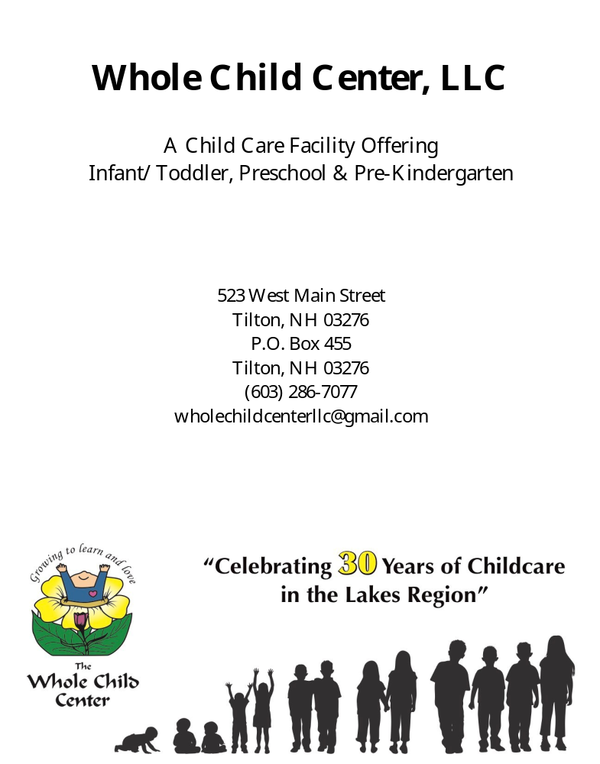

Mission Statement
The Whole Child Center, LLC seeks to provide a safe, caring learning environment which supports the development of prosocial interactions of each and every child. We value individual needs of our children and their families through encouraging positive and respectful communication within our community. All families and children are welcome regardless of abilities, religious beliefs, sexual orientation or race.

History
The Whole Child Center was founded in 1987 as an inclusive facility for all children regardless of individual needs. The center started with three classrooms and an enrollment of 45 children. Within the first three years we outgrew our facilities and acquired rental space in order to expand.
In the summer of 1997, after 10 years in business, we started construction on our original site. With the new building we were able to eliminate the rental space, have quality space for our children and bring all programs to our original site.
We are now licensed for 116 children, have 7 classrooms and offer programs for children 6 weeks to Pre-kindergarten.
Quality programming is and always has been a priority for us! All of our teachers participate in early childhood training and/or early childhood college classes.

Granite Steps for Quality
This is a state wide initiative providing training, staff support and techniques which support the importance of quality early childhood programming. We are in the beginning phase of this initiative as it started in July of 2022, we qualified for step one in December of 2022. We resubmitted our status for a higher step in late 2023 and qualified for step three in January 2024!

Pyramid Model
Pyramid Model in teaching is a framework which provides staff and families with information and support in guiding children’s social emotional development.
We developed a leadership team in July 2022 to work with a coach to begin the process of implementing this approach school wide.
We teach the value of being safe, kind and responsible within our environment and work collaboratively to provide developmentally appropriate expectations to support children. (See attached flyer)

Early Learning Standards
The Early Learning Standards are used as a framework for early development. The ‘Early Learning Standards’ were developed by a task from the Child Development Bureau Division for Youth and Families NH Department of Health and Human Services; copies are available in the office or the classrooms. The staff is trained annually on implementing these guidelines in our programs.

The Early Childhood Environment Rating Scale
The Early Childhood Environment Rating Scale (ECERS) and the Infant/Toddler Environment Rating Scales (ITERS) are used to determine the quality of our environments and to set improvement goals. We use these scales as guidelines to make sure our environment remains high quality.

Curriculum
All About Preschooler, An Environment Based Curriculum is used as a guide for planning throughout the year. We use a variety of other thematic bases to give the children a wide variety of learning activities throughout the year.
The Creative Curriculum for Infants & Toddlers and Preschool, by: Amy Laura Dombro, Laura J. Colker & Trister Dodge is used along with a variety of early childhood resources published by: The National Association for the Education of Young Children.

Goals and Objectives
- To build a partnership with families by: involving them in their child’s program; listening to and discussing their questions; communicating regularly; offering regular conferences; offer information regarding child development; assisting with community resources and being respective of their values.
- To include families in collaboration of implementing the Pyramid Model and the importance of teaching children our important expectations: being safe, being kind and being responsible.
- To partner with families in creating a culture of kindness, caring and being compassionate for one another.
- To provide developmentally appropriate learning activities which allows children to be actively involved in their learning and ensuring that the curriculum addresses all areas of development: Language/communication, physical, social/emotional and cognitive development.
- To provide a quality, clean environment which enhances early learning.
- To create an environment which supports diversity and makes necessary modifications for individual needs of children and their families.

Illness
WCC follows the NH Standards and Licensing Regulations when determining whether an ill child may remain in child care as well as the National Association for the Education of Young Children.
Exclusion from Child Care:
- 1. The illness prevents the child from participating comfortably in the program’s activities, as determined by the childcare provider.
2. The illness makes the child have a greater need for care that the teachers can manage without compromising the care of other children in the group.
3. The child has persistent symptoms that indicate a more serious virus, ie: Flu, Covid, RSV.

- The symptoms of illness shall include but are not limited to:

- More than one episode of vomiting in one day;
- More than one episode of diarrhea in one day;
- Uncontrolled coughing or wheezing;
- Unusual or extreme fatigue or lethargy;
- Skin lesions which have not been diagnosed or treated by a licensed health practitioner; or
- An oral temperature of 101 degrees Fahrenheit or higher, an under arm temperature of 100 degrees Fahrenheit or higher combined with any of the following:
- Diarrhea;
- Rash;
- Ear ache;
- Sore throat; or
- Vomiting

- When a child exhibits symptoms of illness as specified in (A) or (B) above, child care personnel shall contact the child’s parent and inform them of the need to remove their child from the program.

- Child care personnel shall provide any child who is ill an opportunity to rest or do a quiet activity in a comfortable, private, supervised area until the parents arrive to pick up the child.

- When any child care personnel or children in the program have symptoms of or are known to have a communicable disease, the family child care provider, center director, or his/her designee shall contact the bureau of disease control and prevention for instructions regarding whether the ill individual is required to be excluded from the program and to determine reporting requirements in accordance with RSA 141-C: 7 and HeP 301.03 etc. Refer to State Licensing Rules page 45.
Procedures for an ill child:
- Allow the child to rest, or do a quiet activity
- Take the child’s temperature
- Report to the director or the supervisor, after observing, document.
- The director, supervisor, or teacher will call the child’s parents, guardians, or alternate pick up, and let them know:
  - The child’s symptoms;
  - The procedures you have followed at this time;
  - Whether the child should be picked up as soon as possible
- If the child remains at the center:
  - Observe closely for any change in symptoms;
  - Pay close attention to the child’s temperature by checking it every hour
- If the child is waiting to be picked up:
  - Make the child as comfortable as possible, allow to rest, or do a quiet activity;
  - Place in a quiet area away from the other children

- If the child does not have a temperature, and you are unsure whether the child should be picked up, call the parents, legal guardian, or alternate pick up, to explain your concerns, and let them decide.

Other WCC Policy Conditions of Exclusion:
- A temperature of 100.4 degrees Fahrenheit or above
- Contagious diseases (may return after 24 hours after beginning an antibiotic, or prescribed medication by their doctor, or a doctor’s note)
- Vomiting
- Undiagnosed rashes
- Head lice
- Scabies

Parent and Staff Communication
- All communication regarding The Whole Child Center’s staff, students, policies, and procedures must be communicated as follows:
  - With confidentiality;
  - In a professional manner;
  - Must be done at The Whole Child Center. If a staff member is not able to reach a parent during school hours, an evening phone call may be necessary to set up an appointment or to communicate a classroom activity.
- The following methods of parent communication will be used:
  - Monthly classroom newsletters/ quarterly office newsletters
  - Telephone calls
  - Conferences
  - Written note
  - Progress reports
  - ClassDojo
- All issues and concerns involving a student must be communicated to the parent.
- Any and all information regarding students is confidential and shall not be discussed outside of the center with any other individuals, including staff. Immediate termination can result in discussing students, parents or staff outside of the center in an inappropriate manner.

Behavior Management
The Whole Child Center implements a positive pro-social approach to behavior management and classroom participation. The teachers recognize positive behavior verbally, with affection and with bright moment notes. We as a center work to teach children the developmentally appropriate expectations (Safe, kind and responsible) in each classroom. If the children are not responding to the expectations taught and are having difficulty participating, the following steps will be taken:
- Conference with the families
- Develop strategies as a team to try alternative approaches
- Each classroom teacher will designate an appropriate “calming down” or “quiet area, i.e., table activity, book area or an area that is easily observed to make sure the child does not need additional support.
- Each Classroom will be taught the expectations of the “calming down” area and taught how to use the “Turtle Technique” (see attached Handout)
  - Aggressive behavior- any behavior that puts any child’s safety at risk must leave the classroom and go to a calm area (kitchen, office)
  - Non-compliant behaviors- expectations will be reviewed with the child and redirected to another activity. Staff will model and encourage prosocial interactions.
- “Calming down” areas may be inside the classroom, in another classroom, in the kitchen area or office.
- If these techniques are ineffective, the teacher/Director will schedule a conference with the parents and collaboratively come up with a plan that best suits the needs of the child/family.
- When a child has been aggressive with another child:
  - Give immediate attention to the child who may have been hurt; if the child is injured, follow medical procedures.
  - Remove the child exhibiting aggressive behaviors and bring him or her to the “calming down” area.
  - Bring both children back to the situation and redirect with appropriate behavior.
- Document all information regarding severe behaviors that require further intervention.
- To Summarize: When children are aggressive and are not safe to be in the classroom the following will be done:
  - Take the child to a safe place and make sure all children are safe
  - Notify the director immediately
  - Document all incidences
  - Parents will be contacted
  - Parents & teachers will develop a plan to increase pro-social behaviors
  - Regular communication between staff and parents
  - Contact professional assistance if the child is not able to function in the classroom, safety.
- Exclusion only when the team determines it is not safe for the child or other children.

Whole Child Center provides the following items needed daily

- Nap mats and sheets for rest time
- Milk for children 2 and under at AM snack and lunch time
- Water is served throughout the day for all children
- Extra water cups if forgotten at home

Parents please provide the following daily
- Extra clothes to keep in their cubbies (sweat pants, socks), even if your child is toilet trained. We have been known to do messy projects and have mud play outside.
- Outdoor clothing, we make every attempt to go outside except in extremely bad weather.
- Swim suit & towel during warm weather
- Bug spray & sunscreen
- Blanket for rest time and stuffed animal to cuddle. (please label personal items that stay at school, we make every attempt to make sure personal items are returned to children’s cubbies)
- Lunch & a few snacks daily (please pack and ice pack to keep cold)
- Spare snacks if needed depending on your child’s appetite.

Old Clothing items that can be donated, which we never have enough of
- Sweatpants
- Socks
- Mittens, mittens, and more mittens
- Bath towels

Hours of operation
We are open at 6:30 AM and close at 5:30 PM, Monday through Friday. The full time tuition rate includes any hours during those times. However, if a parent is constantly late for pick-up, a fee of $2.50 per minute will be applied to the account.

Holiday Schedule
We are closed for the following Federal Holidays annually
- New Year’s Day
- Memorial Day
- The week of July 4th
- Labor Day
- Thanksgiving Day and the day after
- Christmas Eve Closing at noon
- Christmas Day
Some years if the holiday falls on a weekend we may choose to take either the Friday before off or the Monday after. We will always post any closings on the main doors to the building.
When the public school delays, cancels or releases early, we are open for child care. However, on rare occasions if the State of NH declares a weather emergency and asks the public to stay off the roads, we may need to close the center. Other occasions that may force us to close could be no electricity, heat, or water. Other times we will announce on our Class Dojo, post on the main doors, and on the local radio station WFTN 94.1 FM.

Tuition/Payment Schedule
Tuition is based on each child’s enrollment schedule, not the number of days in attendance. Therefore, the tuition is the same each week even if your child is absent. If your child is enrolled on a part time basis and is out part of their regularly scheduled days, we will make every effort for you to make up those days if enrollment allows.

- All tuition is due on Monday of each week.
- There will be a late charge of $20.00 applied to your account for all payments received after 11:00 AM on Wednesdays.
- If your account is two weeks past due, you will be asked to remove your child until the balance is paid in full. We will make every effort to assist you with finding tuition assistance.

Timely payments reflect on the quality of our programs, if your payment is late it not only affects your child, but the other children as well.

Incentives for families that pay in advance and stay current:

- If tuition is paid one month in advance for a 12 month period, the family will be entitled to a one week paid childcare expense during a family vacation.
- If tuition is paid at the beginning of each week for a 12 month period, the family will be entitled to a 50% off childcare expense during a family vacation.

Weekly Rates (as of 6/01/2026)
- Infant Care (6 weeks- 6 months- $325.00
- Infant Care (6 months- 12 months)- $315.00
- One Year Old Class (12- 24 Months)-$290.00
- Two Year Old Class (2 yrs- 3 yrs)-$280.00
- Three Year Old Class (3 yrs- 4yrs)- $270.00
- Preschool/Pre-Kindergarten (4yrs-5yrs)-$270.00

Payment Methods
Whole Child Center accepts the following forms of payment:
- ACH- Bank Account/ Routing #(Weekly or Monthly Reoccuring)
- Check- (Weekly or Monthly- placed in check box by the office)
- Cash-(Weekly or Monthly- Please hand directly to Office)
- Credit Card- (Weekly or Monthly Reoccuring)(Fee)
- Debit Card- (Weekly or Monthly Reoccuring)(Fee)
*While we offer credit card payments for convenience, families are encouraged to use check, cash, or ACH whenever possible to help minimize processing costs.*

Credit/Debit Card Registration Fee
Families who elect to pay tuition by Credit/Debit card will be charged an annual credit card registration fee of $200 per child.
Credit card processing fees cost the center approximately $400 per child each year. This annual fee helps offset a portion of those expenses and allows us to maintain program quality and pricing.
This fee applies only to card payments and does not apply to ACH, check, or cash payments.

Weekly Payment Processing
- Tuition payments are processed weekly on Fridays.
Monthly Payment Processing
- Tuition payments are processed monthly on the 10th of each Month.

Declined Payment Fee
A $20.00 fee will be applied to any declined credit/debit card or returned ACH/ Check payment.
This fee is intended to cover administrative time and processing costs associated with re-running payments. Families are responsible for ensuring that payment information is current and valid. Sufficient funds must be available at the time of processing.

Avoiding Fees
To avoid additional fees, families should:
- Keep payment information up to date
- Monitor card expiration dates
- Ensure sufficient funds are available on processing days
- Communicate in advance if a payment issue is anticipated

Communication & Support
We understand that occasional financial or technical issues may arise. Families are encouraged to contact the center if assistance is needed. We are committed to working with families whenever possible.

Whole Child Center LLC reserves the right to update this policy as needed. Families will be notified of any future changes.

